# **TEST CASES**

## Test case 1

int a;

if(x==6){

a = "hi";

} else if(y == 2)

int b = 3;

else

int b = 3/(2+5);

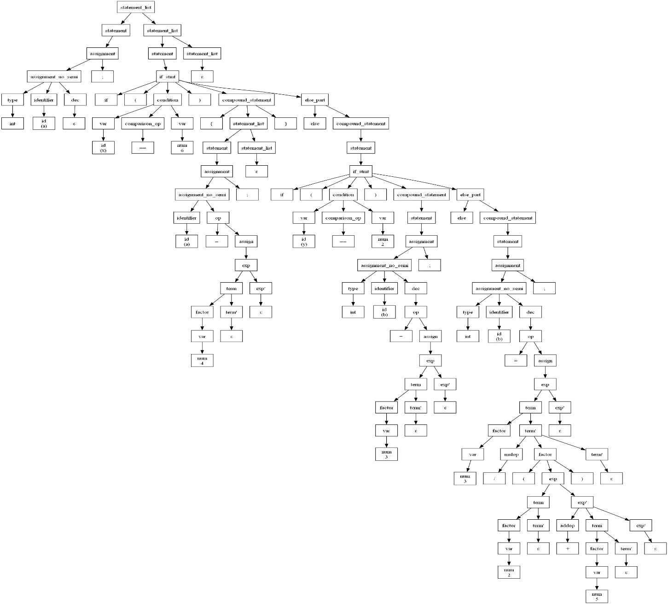

## Test case 2

int x;

int y;

int z;

while(x == 3){

z = y + 2;

}

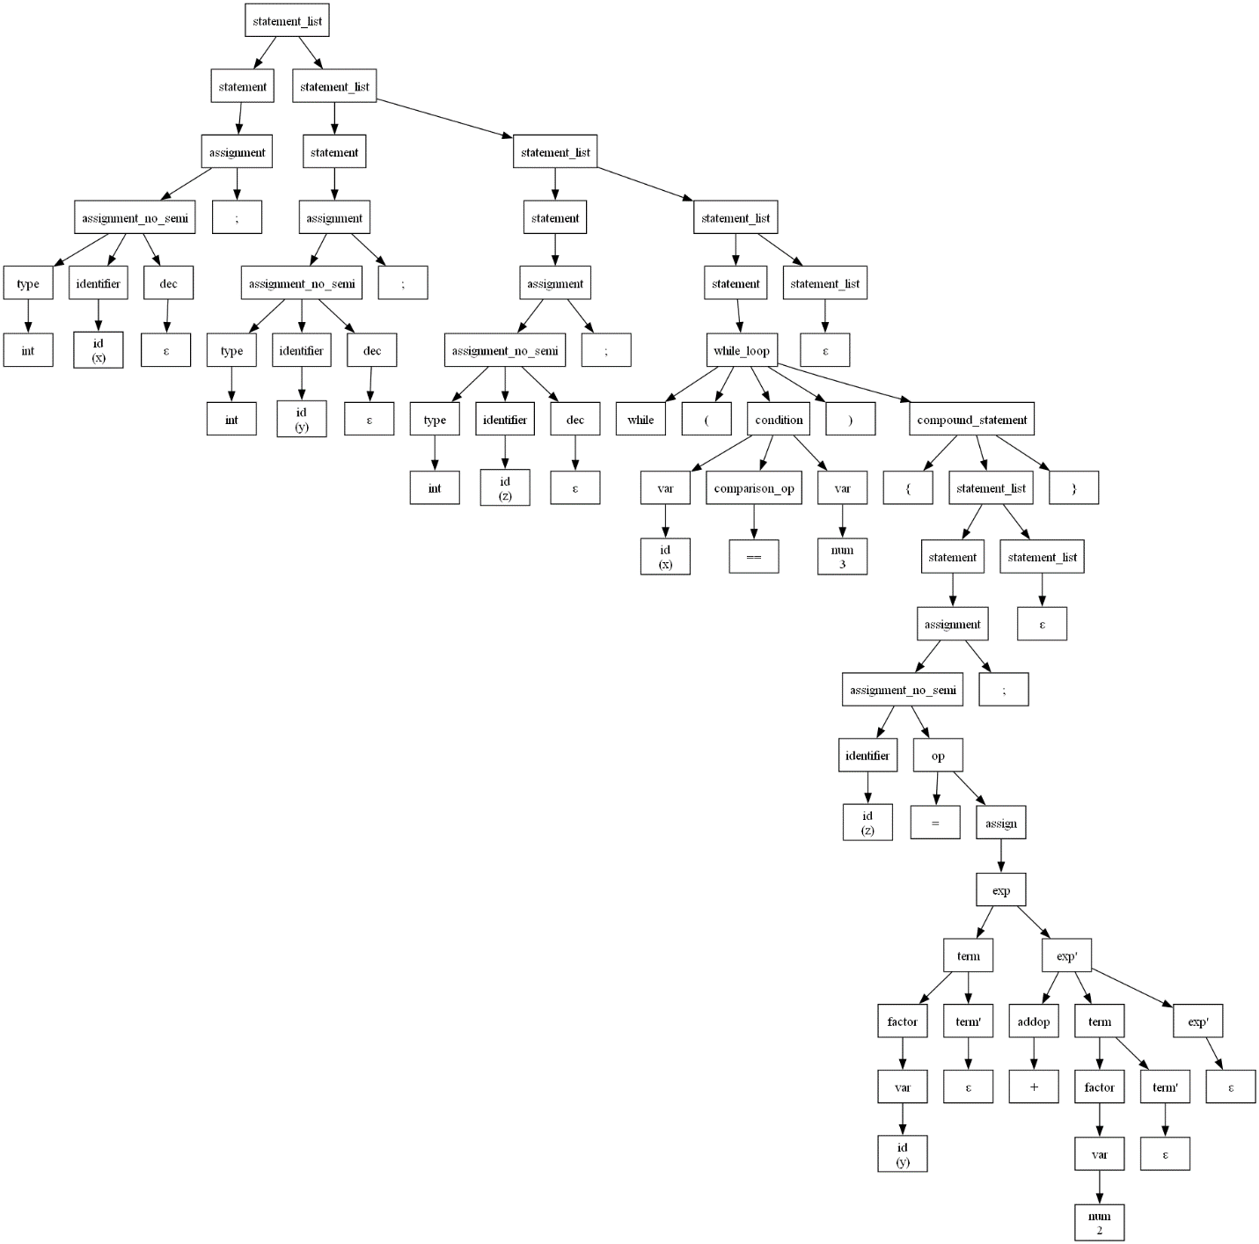

## Test case 3

for(int i = 0; i <= 3; i++){

int x = 0b11;

float pi = 3.14;

double z = 5e3;

}

